SIMATS ENGINEERING
CO2 – ASSESSMENT TOOL-3
Debugging & Optimisation Task

NAME: SHAIK SHOUIB AKTHAR
REG NO: 192312208
Q1:
Debugging & Optimization of Symmetric Encryption (DES / 3DES
Implementation)
A. Identification and Correction of Errors
The main errors in a DES/3DES implementation can occur in the key scheduling and permutation processes. DES uses a 64-bit key, from which 56 effective bits are obtained using the PC-1 permutation. The resulting key is divided into two 28-bit halves, called C and D. These halves are circularly shifted according to the DES shift schedule, and PC-2 is applied to generate sixteen 48-bit round keys.The plaintext is first subjected to the Initial Permutation (IP). It is then divided into left and right halves and processed through 16 Feistel rounds. Each round consists of expansion, XOR operation with the round key, S-box substitution, and P permutation.
Encryption → Decryption → Encryption
Therefore, correcting the key schedule, IP/FP permutations, Feistel operations, padding, and 3DES operation order eliminates most implementation errors.
B. Optimization for Large Datasets
For datasets of 10 MB or more, repeatedly generating round keys and performing unnecessary conversions can increase execution time. The DES round keys should therefore be generated only once and reused for all blocks. Data should be processed using efficient byte operations rather than repeatedly converting between strings and binary representations.
Thus, the major optimization techniques are:
- Generate the key schedule only once.
- Reuse the generated round keys.
C. Replacement with a Modern Cipher
AES (Advanced Encryption Standard) is a better replacement. AES supports 128-bit, 192-bit, and 256-bit keys and uses a 128-bit block size. It provides stronger security and significantly better performance than DES and 3DES, particularly when processing large amounts of data.
Feature | DES | 3DES | AES
Block size | 64 bits | 64 bits | 128 bits
Security | Weak | Legacy | Strong
Speed | Slow | Very slow | Fast
Key size | 56-bit effective | 112/168-bit nominal | 128/192/256 bits
Large data processing | Poor | Poor | Good
Modern use | Not recommended | Not recommended for new systems | Recommended
Program:
from Crypto.Cipher import DES, DES3, AES
from Crypto.Random import get_random_bytes
from Crypto.Util.Padding import pad, unpad
import time

BLOCK_SIZE = 8

def des_encrypt(data, key):
iv = get_random_bytes(BLOCK_SIZE)
cipher = DES.new(key, DES.MODE_CBC, iv)
return iv + cipher.encrypt(pad(data, BLOCK_SIZE))

def des_decrypt(data, key):
iv = data[:BLOCK_SIZE]
cipher = DES.new(key, DES.MODE_CBC, iv)
return unpad(cipher.decrypt(data[BLOCK_SIZE:]), BLOCK_SIZE)

def triple_des_encrypt(data, key):
iv = get_random_bytes(BLOCK_SIZE)
cipher = DES3.new(key, DES3.MODE_CBC, iv)
return iv + cipher.encrypt(pad(data, BLOCK_SIZE))

def triple_des_decrypt(data, key):
iv = data[:BLOCK_SIZE]
cipher = DES3.new(key, DES3.MODE_CBC, iv)
return unpad(cipher.decrypt(data[BLOCK_SIZE:]), BLOCK_SIZE)

def test_performance():
data = (b"Symmetric encryption performance testing. " * 250000)

des_key = b"8bytekey"
des3_key = b"12345678abcdefghABCDEFGH"

start = time.perf_counter()
encrypted = des_encrypt(data, des_key)
decrypted = des_decrypt(encrypted, des_key)
des_time = time.perf_counter() - start

start = time.perf_counter()
encrypted3 = triple_des_encrypt(data, des3_key)
decrypted3 = triple_des_decrypt(encrypted3, des3_key)
des3_time = time.perf_counter() - start

print("DES/3DES PERFORMANCE")
print("Data Size:", len(data) / (1024 * 1024), "MB")
print("DES Correct:", decrypted == data)
print("DES Time:", round(des_time, 6), "seconds")
print("3DES Correct:", decrypted3 == data)
print("3DES Time:", round(des3_time, 6), "seconds")

def aes_test():
data = b"Modern encryption testing. " * 250000
key = get_random_bytes(32)
iv = get_random_bytes(16)

start = time.perf_counter()
cipher = AES.new(key, AES.MODE_CBC, iv)
encrypted = cipher.encrypt(pad(data, AES.block_size))
aes_time = time.perf_counter() - start

print("AES Time:", round(aes_time, 6), "seconds")
print("AES is faster and more secure than DES/3DES.")

if __name__ == "__main__":
test_performance()
aes_test()

Terminal output after running in VS Code:
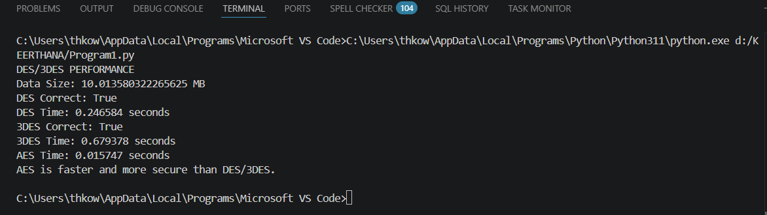
Q2:
Performance Analysis of Block Cipher Modes of Operation
A Python script implements AES-like block cipher modes (ECB, CBC, CFB, OFB)
but suffers from high latency and memory inefficiency.
A. Debugging Padding and IV Handling
Different block cipher modes handle data differently.
- ECB: Does not require an IV, but identical plaintext blocks produce identical ciphertext blocks. Therefore, it is not recommended for secure communication.
- CBC: Requires a unique and unpredictable IV for encryption. Plaintext must be padded to the AES block size.
- CFB: Uses an IV and behaves like a stream mode. Padding is generally not required.
- OFB: Uses an IV and also behaves like a stream mode. Padding is generally not required.
A common decryption failure occurs when the encryption and decryption sides use different IVs or when padding is applied during encryption but not correctly removed during decryption.
The correct process is:
CBC/ECB:
Plaintext → Padding → Encryption → Ciphertext → Decryption → Unpadding → Plaintext
CFB/OFB:
Plaintext → Encryption → Ciphertext → Decryption → Plaintext
B. Reducing Computation and Memory Usage
Performance can be improved by avoiding repeated creation of cipher objects, unnecessary data conversions, and unnecessary copies of large byte arrays.
Important optimization techniques include:
- Use bytes/bytearray instead of repeatedly converting strings.
- Generate the IV once for each encryption session.
- Avoid padding for CFB and OFB.
- Process large data in chunks instead of creating many temporary objects.
C. Comparison of Modes
Mode | IV Required | Padding | Security | Real-time Suitability
ECB | No | Yes | Poor | Not recommended
CBC | Yes | Yes | Good | Moderate
CFB | Yes | No | Good | Very good
OFB | Yes | No | Good | Very good
For real-time secure communication, CFB and OFB can provide low-latency streaming behavior because they do not require padding and can process data without waiting for a complete final padded message. However, in modern applications, an authenticated encryption mode such as AES-GCM is generally preferable because it provides both confidentiality and integrity.
Program:
from Crypto.Cipher import AES
from Crypto.Random import get_random_bytes
from Crypto.Util.Padding import pad, unpad
import time
BLOCK_SIZE = AES.block_size

def encrypt_ecb(data, key):
cipher = AES.new(key, AES.MODE_ECB)
return cipher.encrypt(pad(data, BLOCK_SIZE))

def decrypt_ecb(data, key):
cipher = AES.new(key, AES.MODE_ECB)
return unpad(cipher.decrypt(data), BLOCK_SIZE)

def encrypt_cbc(data, key):
iv = get_random_bytes(BLOCK_SIZE)
cipher = AES.new(key, AES.MODE_CBC, iv)
return iv + cipher.encrypt(pad(data, BLOCK_SIZE))

def decrypt_cbc(data, key):
iv = data[:BLOCK_SIZE]
cipher = AES.new(key, AES.MODE_CBC, iv)
return unpad(cipher.decrypt(data[BLOCK_SIZE:]), BLOCK_SIZE)

def encrypt_cfb(data, key):
iv = get_random_bytes(BLOCK_SIZE)
cipher = AES.new(key, AES.MODE_CFB, iv)
return iv + cipher.encrypt(data)

def decrypt_cfb(data, key):
iv = data[:BLOCK_SIZE]
cipher = AES.new(key, AES.MODE_CFB, iv)
return cipher.decrypt(data[BLOCK_SIZE:])

def encrypt_ofb(data, key):
iv = get_random_bytes(BLOCK_SIZE)
cipher = AES.new(key, AES.MODE_OFB, iv)
return iv + cipher.encrypt(data)

def decrypt_ofb(data, key):
iv = data[:BLOCK_SIZE]
cipher = AES.new(key, AES.MODE_OFB, iv)
return cipher.decrypt(data[BLOCK_SIZE:])

def test_mode(name, encrypt, decrypt, data, key):
start = time.perf_counter()
encrypted = encrypt(data, key)
encryption_time = time.perf_counter() - start

start = time.perf_counter()
decrypted = decrypt(encrypted, key)
decryption_time = time.perf_counter() - start

print(name)
print("Encryption Time:", round(encryption_time, 6), "seconds")
print("Decryption Time:", round(decryption_time, 6), "seconds")
print("Correct:", decrypted == data)
print()

data = b"AES block cipher performance testing. " * 250000
key = get_random_bytes(32)

print("Data Size:", round(len(data) / (1024 * 1024), 2), "MB")
print()

test_mode("ECB", encrypt_ecb, decrypt_ecb, data, key)
test_mode("CBC", encrypt_cbc, decrypt_cbc, data, key)
test_mode("CFB", encrypt_cfb, decrypt_cfb, data, key)
test_mode("OFB", encrypt_ofb, decrypt_ofb, data, key)
Terminal output after running in VS Code: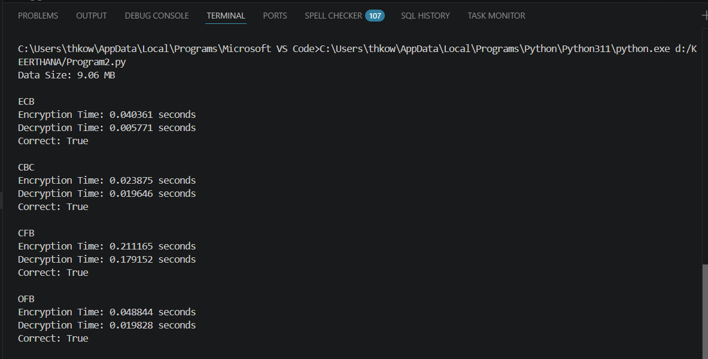

3. Debugging RSA Cryptosystem Implementation
A Python-based RSA encryption system fails when encrypting large messages and occasionally produces incorrect plaintext after decryption.
A. Identification of Issues
The first issue is prime generation. RSA requires two large, distinct prime numbers, p and q. If the generated numbers are not prime or are too small, the security and correctness of the system are affected. A reliable primality-testing method should be used.
The second issue is key generation. The modulus is calculated from the two prime numbers, and the public exponent must be relatively prime to the Euler totient. The private key is obtained as the modular inverse of the public exponent. An incorrect modular inverse results in incorrect decryption.
B. Optimization
RSA performance can be improved using fast modular exponentiation, which performs repeated squaring and modular reduction instead of calculating the complete large power. This significantly reduces computation time.
C. Key Size, Security and Performance
The RSA key size directly affects security and performance. Smaller keys require less computation but provide weaker security. Larger keys provide stronger protection but require more processing time and memory.
A 2048-bit RSA key is commonly used as a practical baseline for modern applications, while 3072-bit or larger keys provide higher security with increased computational cost. Very small RSA keys such as 512-bit and 1024-bit are not suitable for modern secure applications.
Program:
from Crypto.Util.number import getPrime, inverse
import time

def generate_keys(bits=1024):
p = getPrime(bits)
q = getPrime(bits)
n = p * q
phi = (p - 1) * (q - 1)

e = 65537
d = inverse(e, phi)

return (e, n), (d, n)

def encrypt(message, public_key):
e, n = public_key
m = int.from_bytes(message, "big")

if m >= n:
raise ValueError("Message is too large")

return pow(m, e, n)

def decrypt(ciphertext, private_key):
d, n = private_key
m = pow(ciphertext, d, n)
length = (m.bit_length() + 7) // 8
return m.to_bytes(length, "big")

def test_rsa():
message = b"RSA cryptosystem performance testing"

start = time.perf_counter()
public_key, private_key = generate_keys()
key_time = time.perf_counter() - start

start = time.perf_counter()
ciphertext = encrypt(message, public_key)
encryption_time = time.perf_counter() - start

start = time.perf_counter()
plaintext = decrypt(ciphertext, private_key)
decryption_time = time.perf_counter() - start

print("RSA PERFORMANCE")
print("Key Generation Time:", round(key_time, 6), "seconds")
print("Encryption Time:", round(encryption_time, 6), "seconds")
print("Decryption Time:", round(decryption_time, 6), "seconds")
print("Original Message:", message)
print("Decrypted Message:", plaintext)
print("Correct:", plaintext == message)

test_rsa()
Terminal output after running in VS Code:
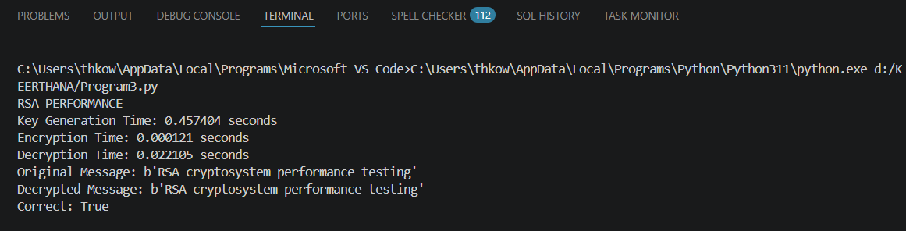
Q4:
Optimization and Security Analysis of Diffie-Hellman Key Exchange
A Python implementation of the Diffie-Hellman key exchange is vulnerable to performance bottlenecks and potential security flaws.
A. Debugging Shared Key Generation
Incorrect shared-key generation can occur because of improper modular arithmetic or incorrect calculation of public and private values. The public key is generated using modular exponentiation, and the shared key is calculated using the other user's public key and the user's own private key.
Both users must obtain the same shared secret. The implementation should correctly apply the modulo operation at every required step. Using efficient modular exponentiation also prevents unnecessarily large intermediate values.
B. Optimization of Exponentiation
For large prime numbers, normal exponentiation can be computationally expensive. Fast modular exponentiation is used to improve performance. It uses repeated squaring and modular reduction, significantly reducing the number of multiplication operations.
The optimized calculation allows the system to handle large prime numbers more efficiently while maintaining the correctness of the shared key.
C. Protection Against Man-in-the-Middle Attack
Basic Diffie-Hellman does not authenticate the communicating parties. Therefore, an attacker can intercept the public values and establish separate keys with each party. This is known as a Man-in-the-Middle (MITM) attack.
The enhanced process is:
Key Generation → Public Key Exchange → Authentication → Shared Secret Generation → Session Key
Authentication adds some computational overhead, but it provides significantly better security.
Program:
import secrets
import time

def generate_private_key(p):
return secrets.randbelow(p - 2) + 2

def generate_public_key(g, private_key, p):
return pow(g, private_key, p)

def generate_shared_key(public_key, private_key, p):
return pow(public_key, private_key, p)

def diffie_hellman():
p = 23
g = 5

start = time.perf_counter()

private_a = generate_private_key(p)
private_b = generate_private_key(p)

public_a = generate_public_key(g, private_a, p)
public_b = generate_public_key(g, private_b, p)

shared_a = generate_shared_key(public_b, private_a, p)
shared_b = generate_shared_key(public_a, private_b, p)

execution_time = time.perf_counter() - start

print("DIFFIE-HELLMAN KEY EXCHANGE")
print("Prime (p):", p)
print("Generator (g):", g)
print("Alice Public Key:", public_a)
print("Bob Public Key:", public_b)
print("Alice Shared Key:", shared_a)
print("Bob Shared Key:", shared_b)
print("Keys Match:", shared_a == shared_b)
print("Execution Time:", round(execution_time, 6), "seconds")

diffie_hellman()
Terminal output after running in VS Code:
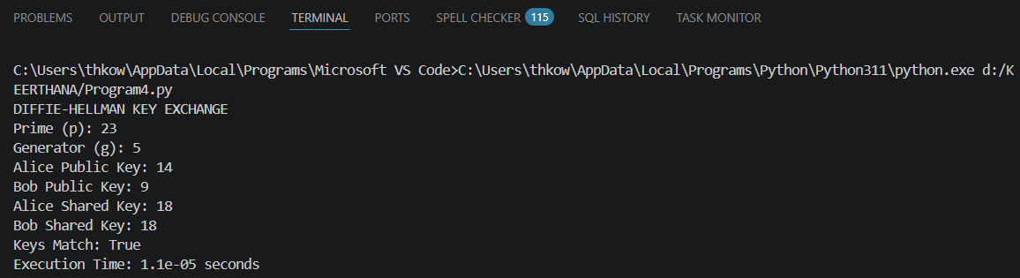
Q5:
Debugging and Enhancing Elliptic Curve Cryptography (ECC) Implementation
A Python script implementing Elliptic Curve Cryptography for key exchange produces incorrect results for certain curve parameters.
A. Identification and Correction of Errors
Incorrect results in an ECC implementation are mainly caused by errors in point addition, point doubling, modular inverse calculation, and scalar multiplication.
Point addition must correctly handle all cases, including adding two different points, adding a point to itself, and adding a point to its inverse. The point at infinity must also be handled correctly. All calculations must be performed modulo the selected prime number.
B. Optimization Using Double-and-Add
Scalar multiplication is an important operation in ECC. It involves multiplying a point by a large integer. Performing repeated point addition for every value of the integer is inefficient.
The double-and-add algorithm improves the performance of scalar multiplication by using the binary representation of the scalar. The point is repeatedly doubled, and point addition is performed only when the corresponding binary bit is 1.
C. Comparison of ECC and RSA
ECC and RSA are both public-key cryptographic algorithms, but ECC provides comparable security with much smaller key sizes.
Parameter | ECC | RSA
Key size | Small | Large
Security | High | High
Processing | Efficient | More computationally intensive
Memory requirement | Low | Higher
Bandwidth requirement | Low | Higher
Resource-constrained devices | Highly suitable | Less suitable
IoT applications | Suitable | Less suitable

Program:
import time
from tinyec import registry

def generate_keys(curve):
private_key = int.from_bytes(
__import__("secrets").token_bytes(32), "big"
) % curve.field.n
public_key = private_key * curve.g
return private_key, public_key

def encrypt(message, public_key, curve):
k = 12345
c1 = k * curve.g
c2 = message + k * public_key
return c1, c2

def decrypt(ciphertext, private_key):
c1, c2 = ciphertext
return c2 - private_key * c1

def main():
curve = registry.get_curve("secp256r1")

message = 100 * curve.g

start = time.perf_counter()

private_key, public_key = generate_keys(curve)

ciphertext = encrypt(message, public_key, curve)
decrypted = decrypt(ciphertext, private_key)

elapsed = time.perf_counter() - start

print("ECC")
print("Private Key:", private_key)
print("Public Key:", public_key)
print("Encryption/Decryption Successful:", decrypted == message)
print("Execution Time:", round(elapsed, 6), "seconds")

main()
Terminal output after running in VS Code:
